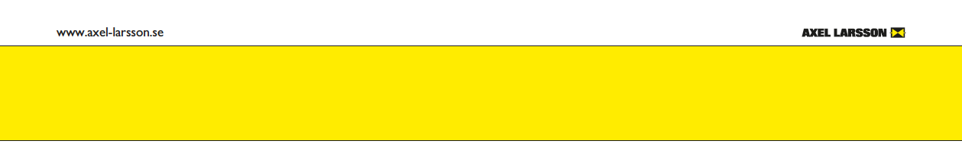**COMPLAINT FORM   
This form must always be filled in and sent along with returned products when making a complaint**

Axel Larsson Maskinaffär AB will accept claimed products only after an agreement. Please contact Axel Larsson Maskinaffär AB, claims@axel-larsson.se for instructions on shipping that adverting goods. Attach this form to the outside of the packaging so that we can easily identify the return when it arrives at our warehouse.

Always enclose a copy of the waybill. In other case the products shall be returned to Axel Larsson Maskinaffär AB

Truckvägen 12

194 52 Upplands Väsby

Sweden.

If we do not receive the claimed product within 30 days from when the complaint was initiated, we will have to close the claim.

|  |  |  |  |  |  |  |
| --- | --- | --- | --- | --- | --- | --- |
| Axel Larsson’s sales person | Date | | | | Axel Larsson’s complaint number | |
|  | 2024-08-28 | | | |  | |
| Axel Larsson’s order number or invoice no. | | | |  | | |
| Axel Larsson’s item number in the order | | | |  | | |
| Product | | | |  | | |
| Article number | | | |  | | |
| Customers complaint number | | | |  | | |
| Company | |  | | | | |
| Contact person | |  | | | | |
| Telephone | |  | | | | |
| E-mail | |  | | | | |
| Customers complaint no. | |  | | | | |
| The product has been installed | | | | YES: | | | NO: |

If the answer above is YES, the sender is responsible for the product to be clean from all hazardous contamination and safe to handle. Please attach safety instructions to the package in case hazardous media has been used in the product.

|  |  |  |
| --- | --- | --- |
| Short description of the defect: | | |
|  | | |
|  |  |  |
|  |  |  |
| We hereby certify that the returned product meets the safety requirements mentioned above. | | |

Date…………………………. Signature………………………………………………………………………………